Abstract
Title: WhatsApp-Based Smart Medication Adherence System with Caregiver Alerts and Adherence Analytics

Abstract:
Taking medicines, the right way is important. This helps treat chronic or acute conditions significantly. However, most patients forget to take their medicines or just become too busy. Such an issue affects the elderly or patients taking long-term medication the most. Conventional methods of reminders through alarms or applications may not always be helpful as not all patients will have equal access to them; moreover, the interface may not be pleasant, and patients might have to download another program. Now, there is the WhatsApp-Based Smart Medication Adherence System. The innovation leverages what is already known to many of us, which is the popularity of WhatsApp. It is like a robocall to adhere to medicines on time. You simply send text messages to schedule your medication. Then, depending on your schedule, automated messages alert you, after which you simply send a report if it is taken or if it is missed. In case of a missed dose, it immediately informs a registered caregiver. The system also records every medication instance and develops medication adherence analytics in the form of daily and weekly reports. Such reports help patients and their caregivers detect patterns of medication adherence over time. It is intended to be very usable and highly accessible by avoiding the need for developing another mobile app—relying on a very popular messaging service that scales very easily. In a nutshell, this strategy presents a very effective mechanism to improve medication adherence and caregiver participation.
- Objectives
The proposed idea intends to develop a reminder system for taking medicines by tracking when the medicines are taken by patients, also sending reminders automatically through the WhatsApp messaging platform. It also plans to identify when medicines are missed by patients, sending alerts immediately to the care giver, along with generating reports daily and weekly. Thus, making use of the WhatsApp platform for interaction makes it more accessible for the reminder system.
- Framework / Architecture
Technology Framework
- Frontend Interface: WhatsApp Messaging Platform
- Backend Server: Python with Flask Framework
- Messaging API: Twilio WhatsApp API
- Scheduler: APScheduler
- Database: SQLite
Three-tier architecture is followed by this system. Input, Processing, and Output tier levels are included here. This system aims to provide real-time interaction, scheduling, monitoring, and notifications to caregivers via WhatsApp.
The service is relied upon by users for medication information to be shared with the application. The backend server is responsible for medication reminders and report generation based on user-provided medication consumption details. Caregivers get notifications when a medication is missed.
Layer-wise Explanation
1. Input Layer
The input layer represents user interaction with the system. Patients provide medication-related inputs through WhatsApp messages using simple text commands. This layer ensures ease of use, especially for elderly users, by eliminating the need for specialized applications.
Inputs include:
- Medication name and time
- Intake confirmation (Taken / Missed)
- Report requests
2. Communication Layer
The communication layer is the bridge that joins WhatsApp with the back-end system. The Twilio WhatsApp API securely relays messages received from the users to the back-end server and sends notifications back to WhatsApp.

3. Processing Layer
This represents the core layer of this system, in which all logics occur. The backend server deals with commands from users, error validation, reminders, adherence, and notifications for caregivers, depending on when they have to happen.
Key components include:
- Command parsing module
- Time-based scheduling engine
- Adherence monitoring logic
- Report generation module
4. Data Layer
The data layer stores all real-time medication data generated by users. A lightweight SQLite database is used to maintain medication schedules, intake status, and timestamps. This data supports adherence analytics and report generation.
5. Output Layer
The output layer delivers results back to users and caregivers. Patients receive reminders and confirmations, while caregivers receive alerts for missed doses. The system also provides adherence reports for monitoring purposes.
Architecture Significance
- Ensures real-time communication
- Supports scalability and modularity
- Enables caregiver intervention
- Requires no mobile application installation
Designed for healthcare accessibility
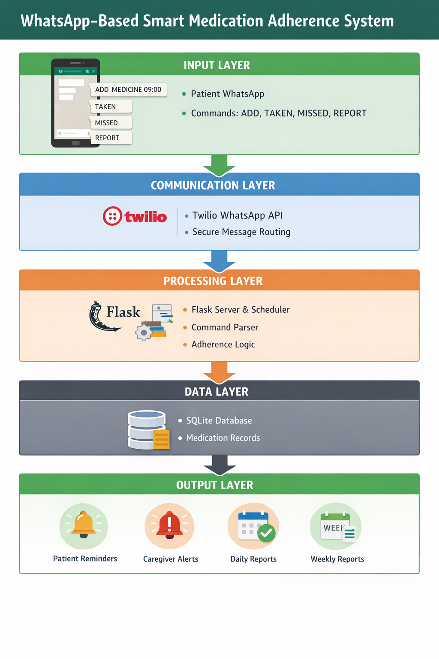
Fig 3.1: architecture of the proposed system

